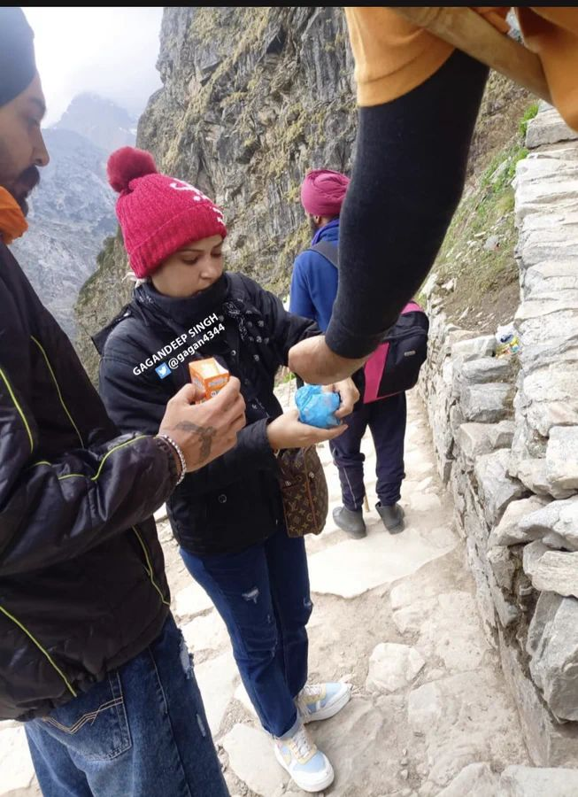
How to catch wanted criminals using behavioural science?

Problem statement- Catching a couple wanted for an 8.5 Crore heist.

Behavioural Tool used- 10 rs Frooti? 🤔

Well, I'm sure nobody in the Punjab police had a degree in behavioural science, but by the end of this post, you'll realise how ingenious their plan was, playing heavily on what we mere mortals of the field call "defaults".

Wee hours of June 10. As the city of Ludhiana was waking up from its peaceful slumber- Mandeep Kaur, now being called "Daaku Haseena" along with her husband, brother and 10 accomplices had executed her plan of looting 8.49 Crores from a cash van.

Interestingly, her 18-Year-old brother had also uploaded a reel bragging about the heist- but that is a Gen Z thing we'll talk about some other day.

Ludhiana Police launched an operation named "Cage theQueen Bee".

The tip they received that changed the course of the case?

The first thing these thieves planned on doing after the robbery was going on a pilgrimage to Hemkund Sahib in Uttarakhand- thanking the lord for their success. Pretty humble, god-fearing people now, aren't they?

I guess that is why god decided to bring them to justice so they do not carry bad karma in the afterlife- In a very sweet way.

Punjab police mobilised quickly- they placed their personnel at key passing points and started distributing Frooti packs- the nation's favourite mango-flavoured beverage.

On their way back from the holy grounds, the naughty-naughty couple couldn't help but fall to the lure of a refreshing sip of Frooti- revealing their faces to help their parched throats.

And that was it, under 100 hours, Punjab Police had nabbed them- and recovered 6.96 crore, with the help of a 10 rs beverage.

Our default systems are powerful- it is biology and psychology together tweaking our behaviour in rather predictable ways which seem totally irrational- but are deeply embedded in our design.

You do not take frooti from strangers when you are on the run, you definitely do not go to a public place of worship after a major heist- and you certainly should not post about it on Instagram.

But taking pride, religion, hunger and thirst- are all very fundamental to what creates people's context.

Everyone loves stuff being handed out for free!

You do not need a degree to tap into these things- you just need to observe people enough and apply it in the situations that fit best.

Fun fact- After being nabbed they realised 1 cr from the heist was actually stolen from their own car- by an accomplice.

You absolutely do not trust someone who helped you steal stuff.

